Deployments steps

Creating pinecone vectorstore
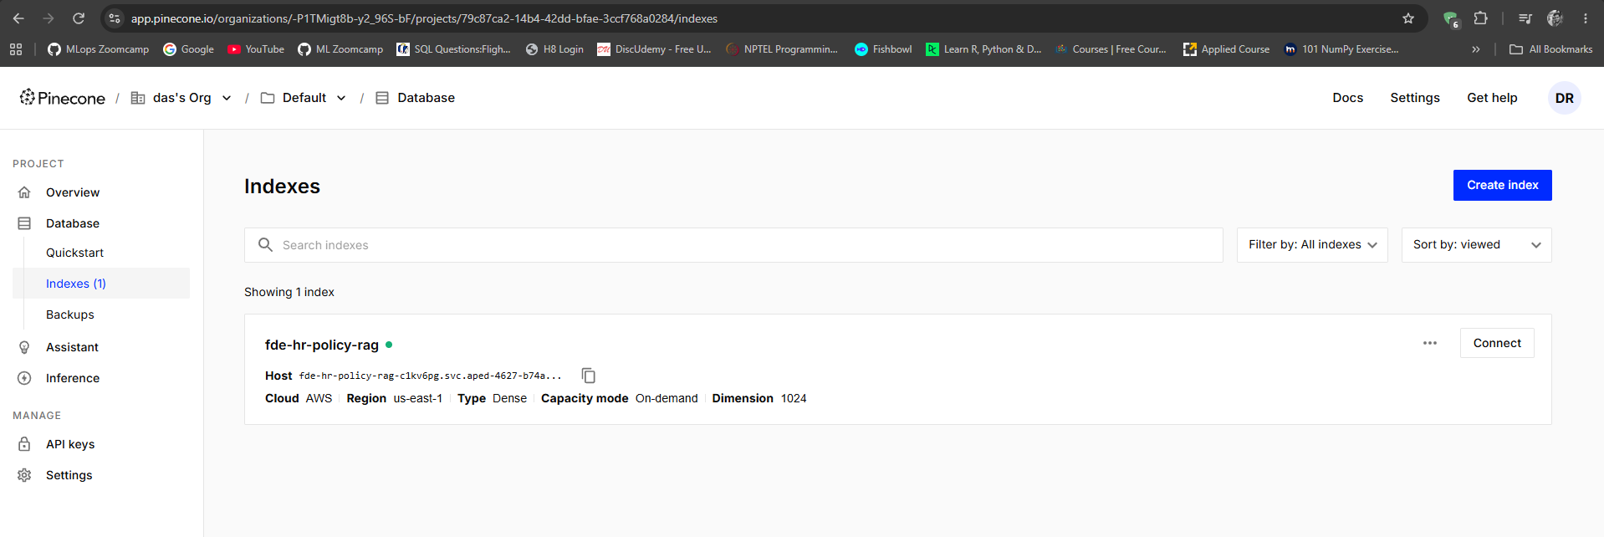
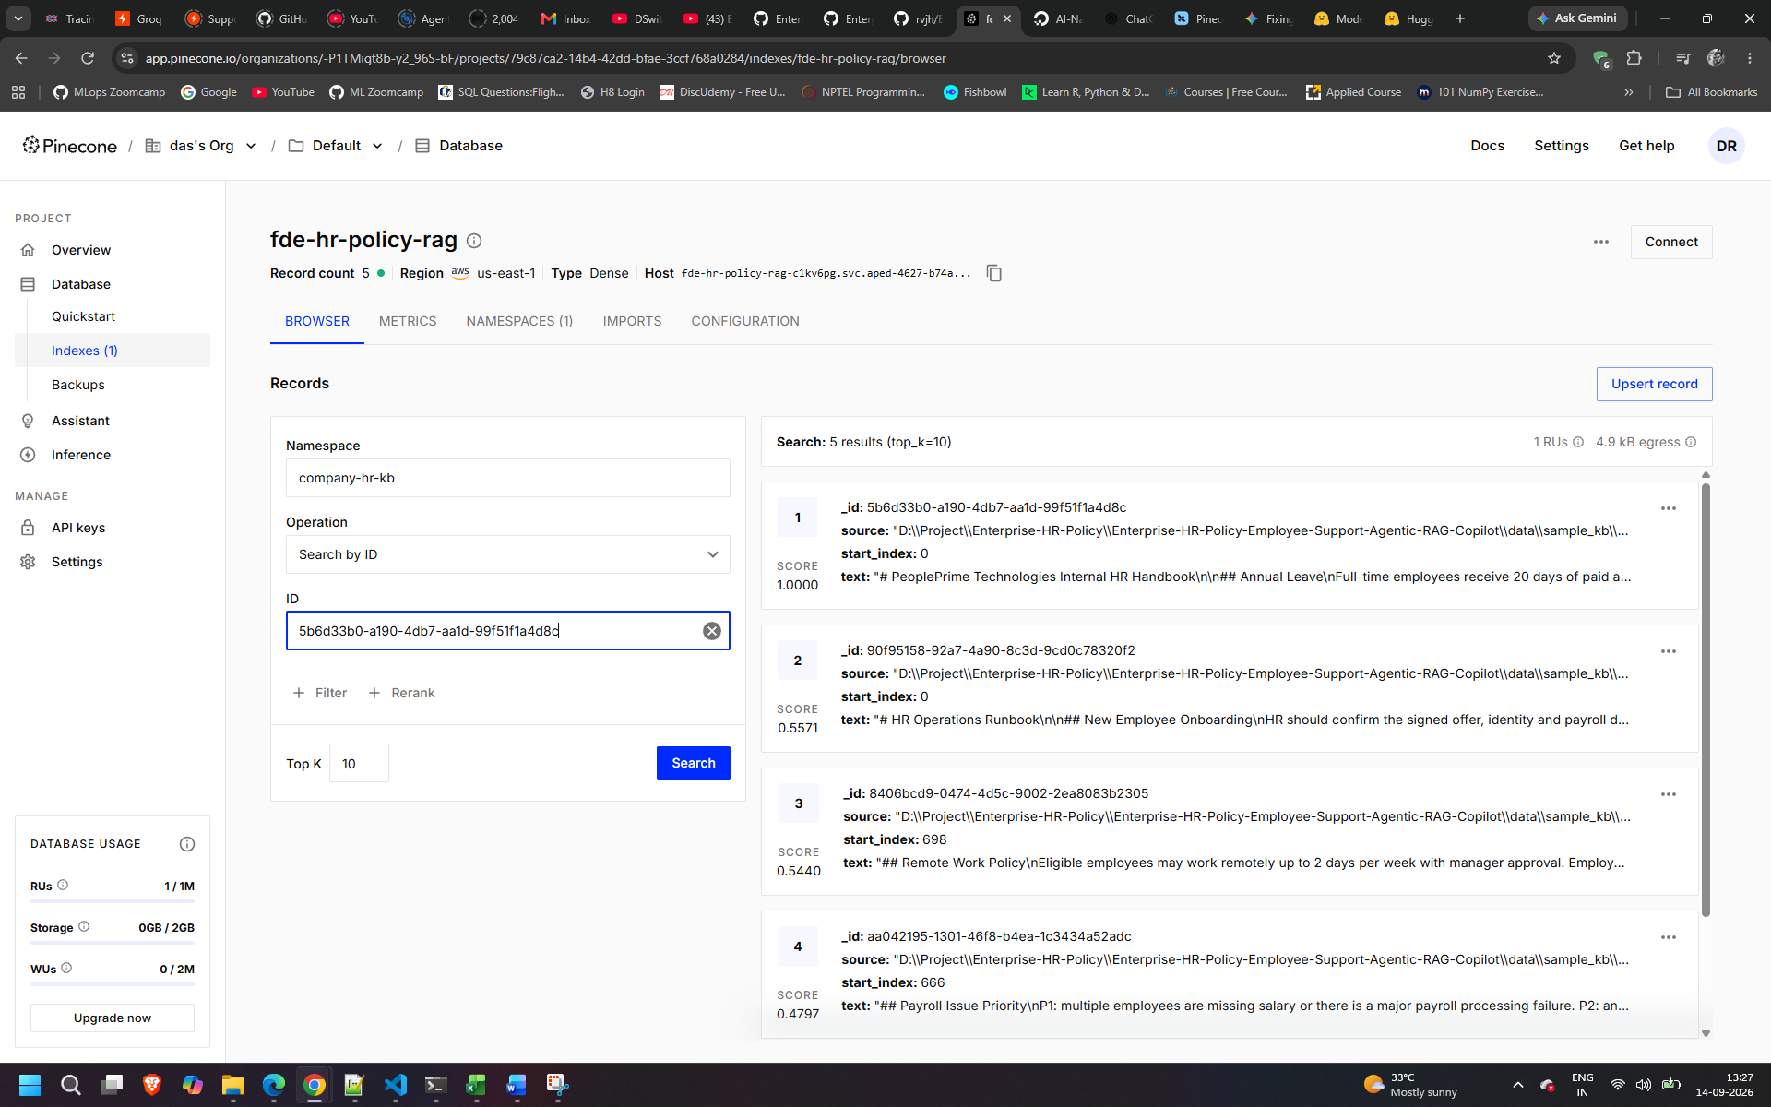
Before running the below make sure you run ingest_sample_kb.py – so that your knowledge base will be available from pinecone
Now
Run python run.py
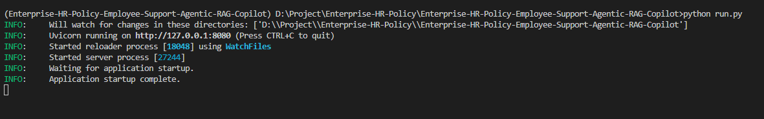
First UI : http://127.0.0.1:8080/
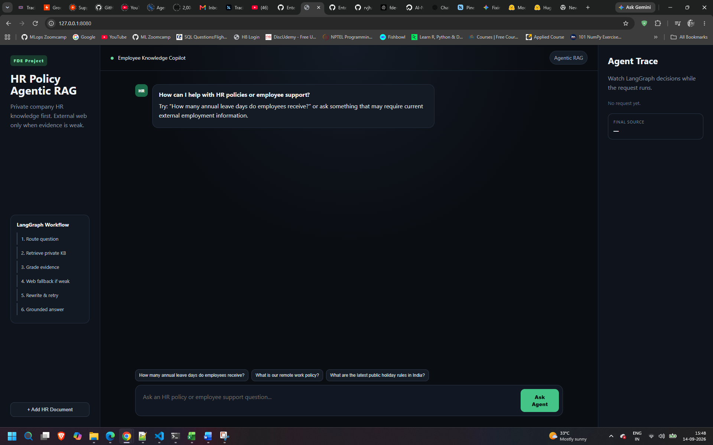

If you want to upload external documents then click on add HR documents – follow the next steps
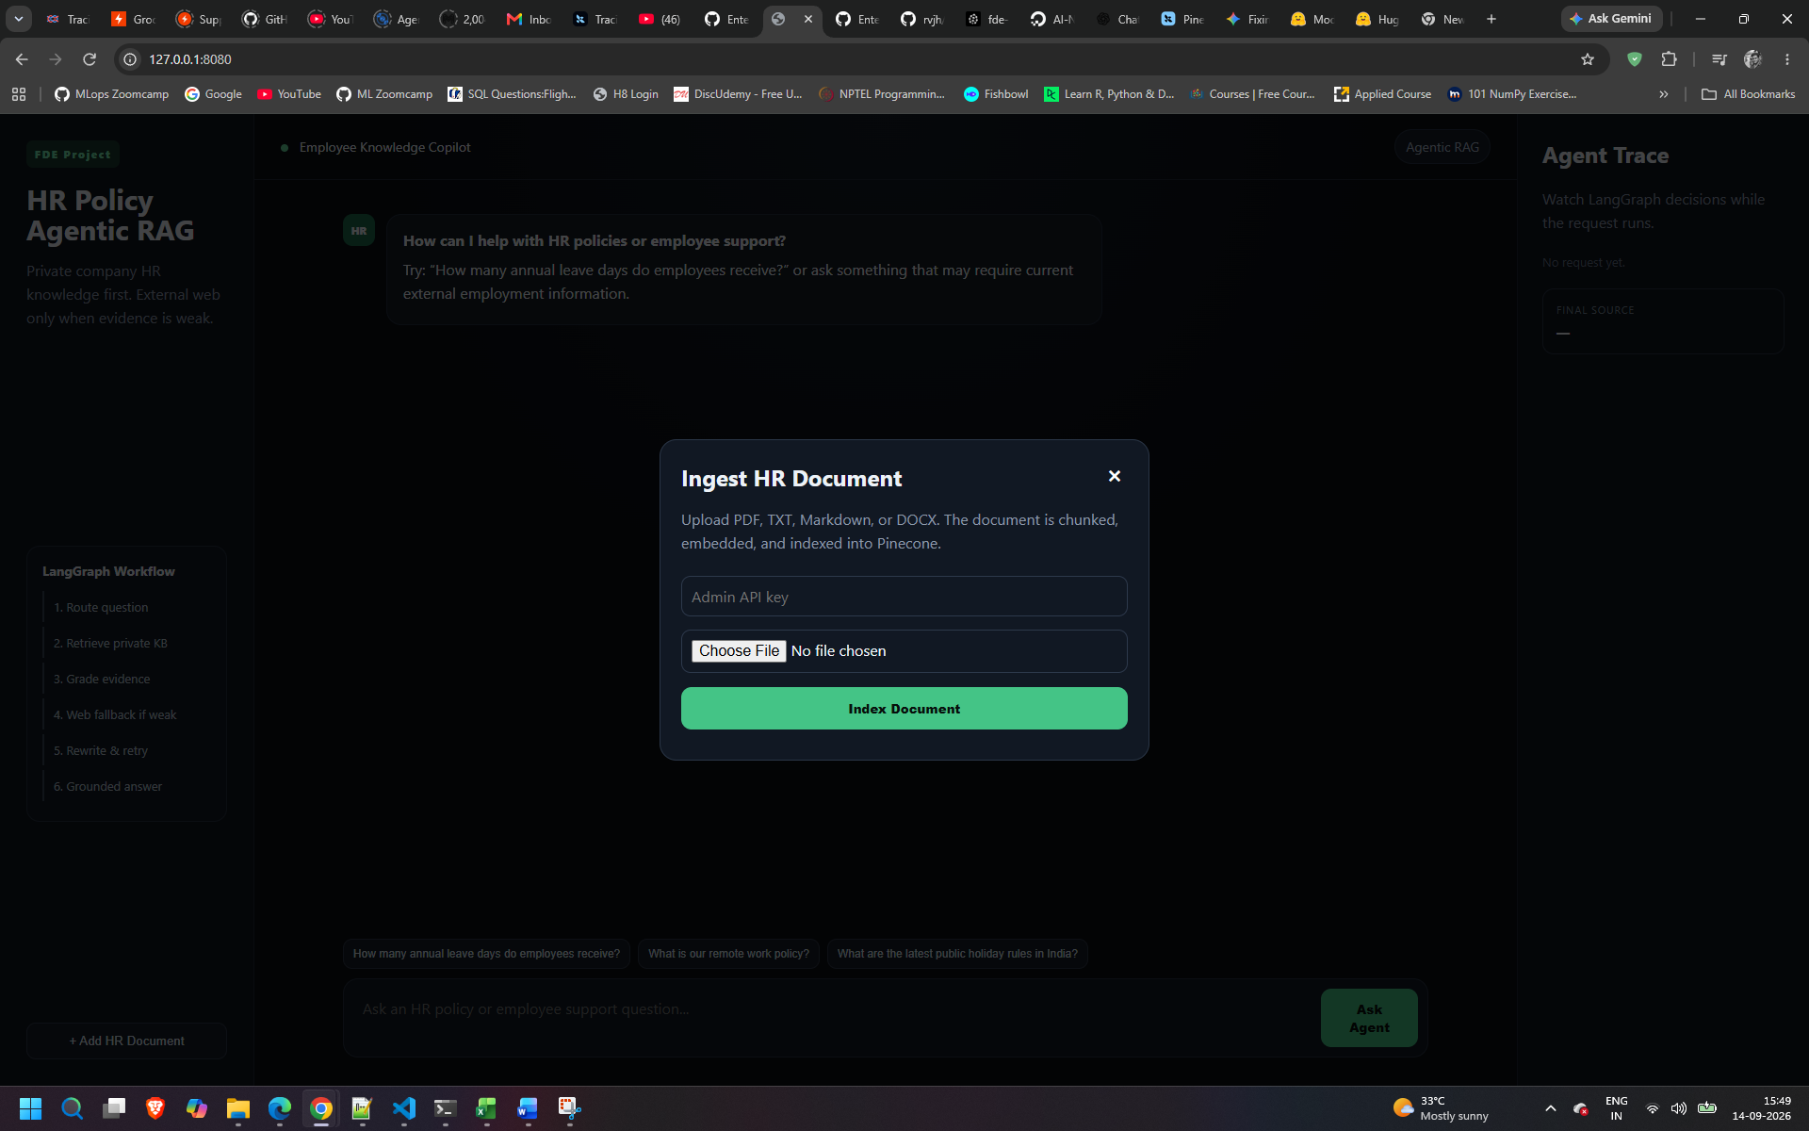
Lets test with some basic questions

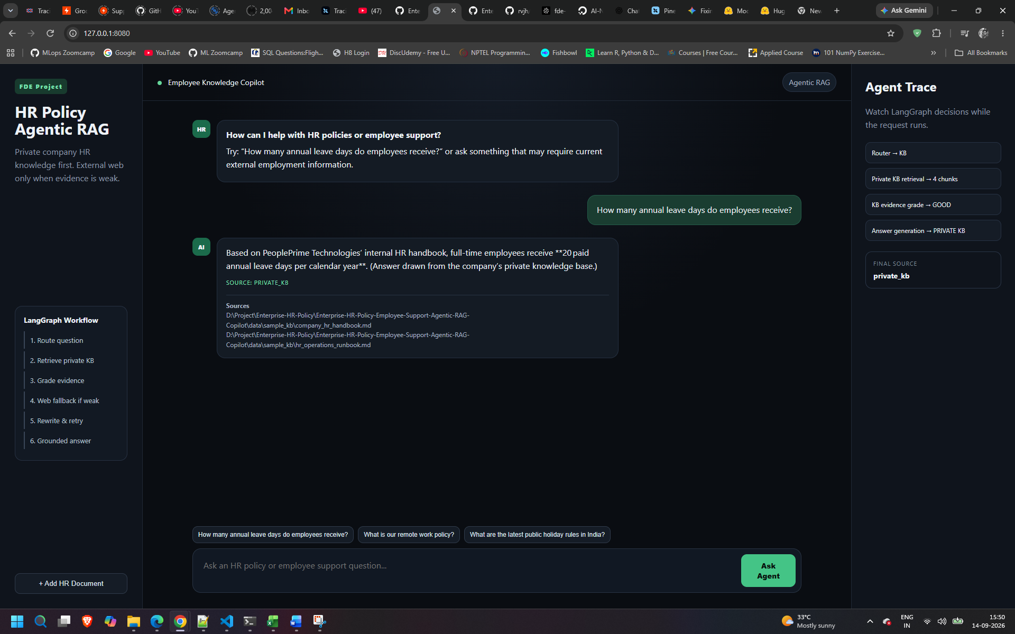
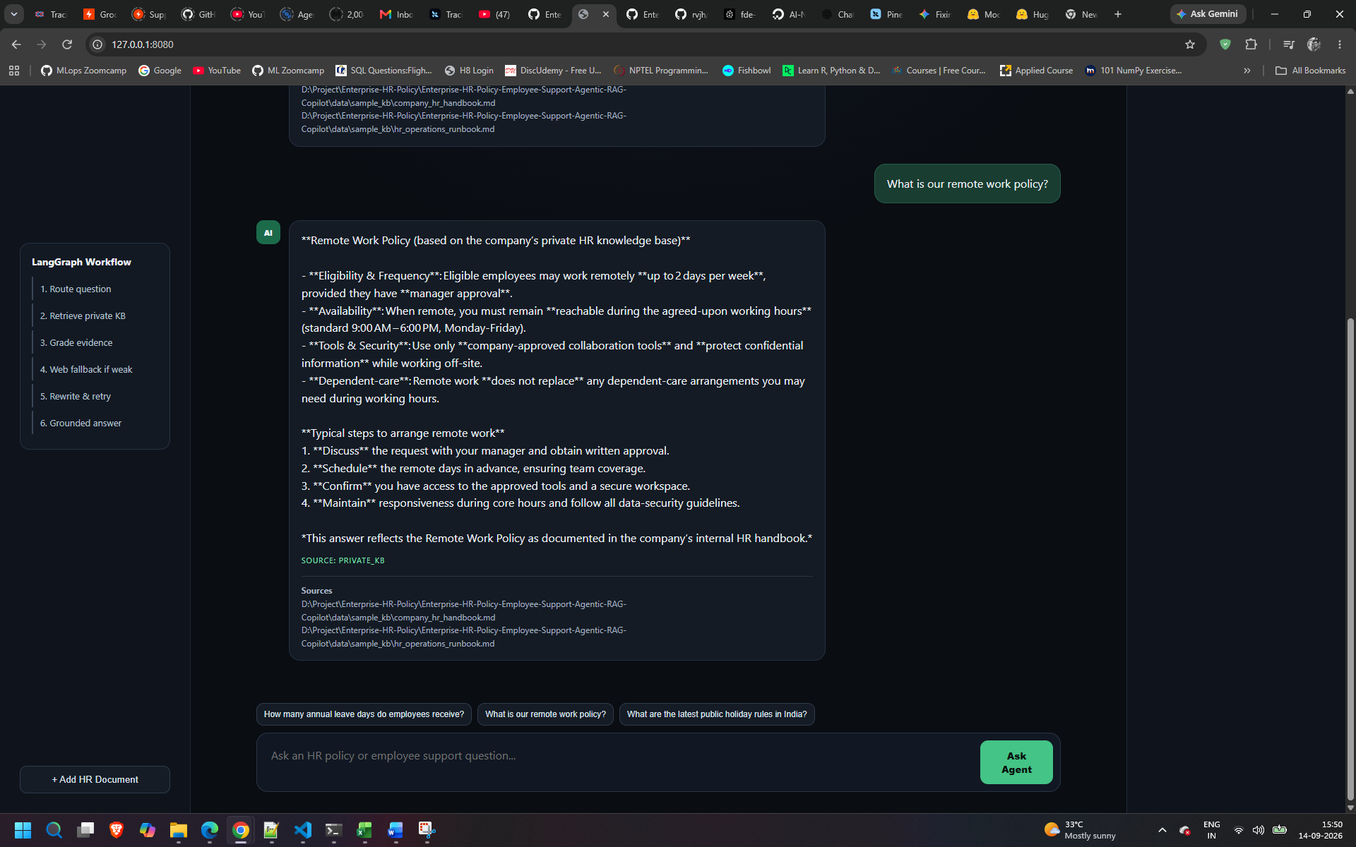
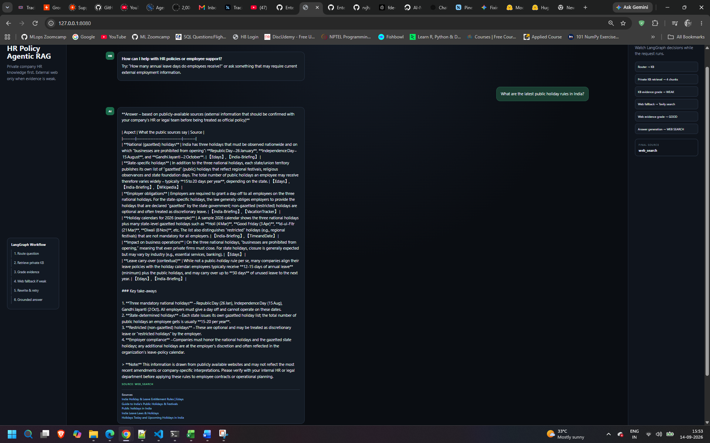
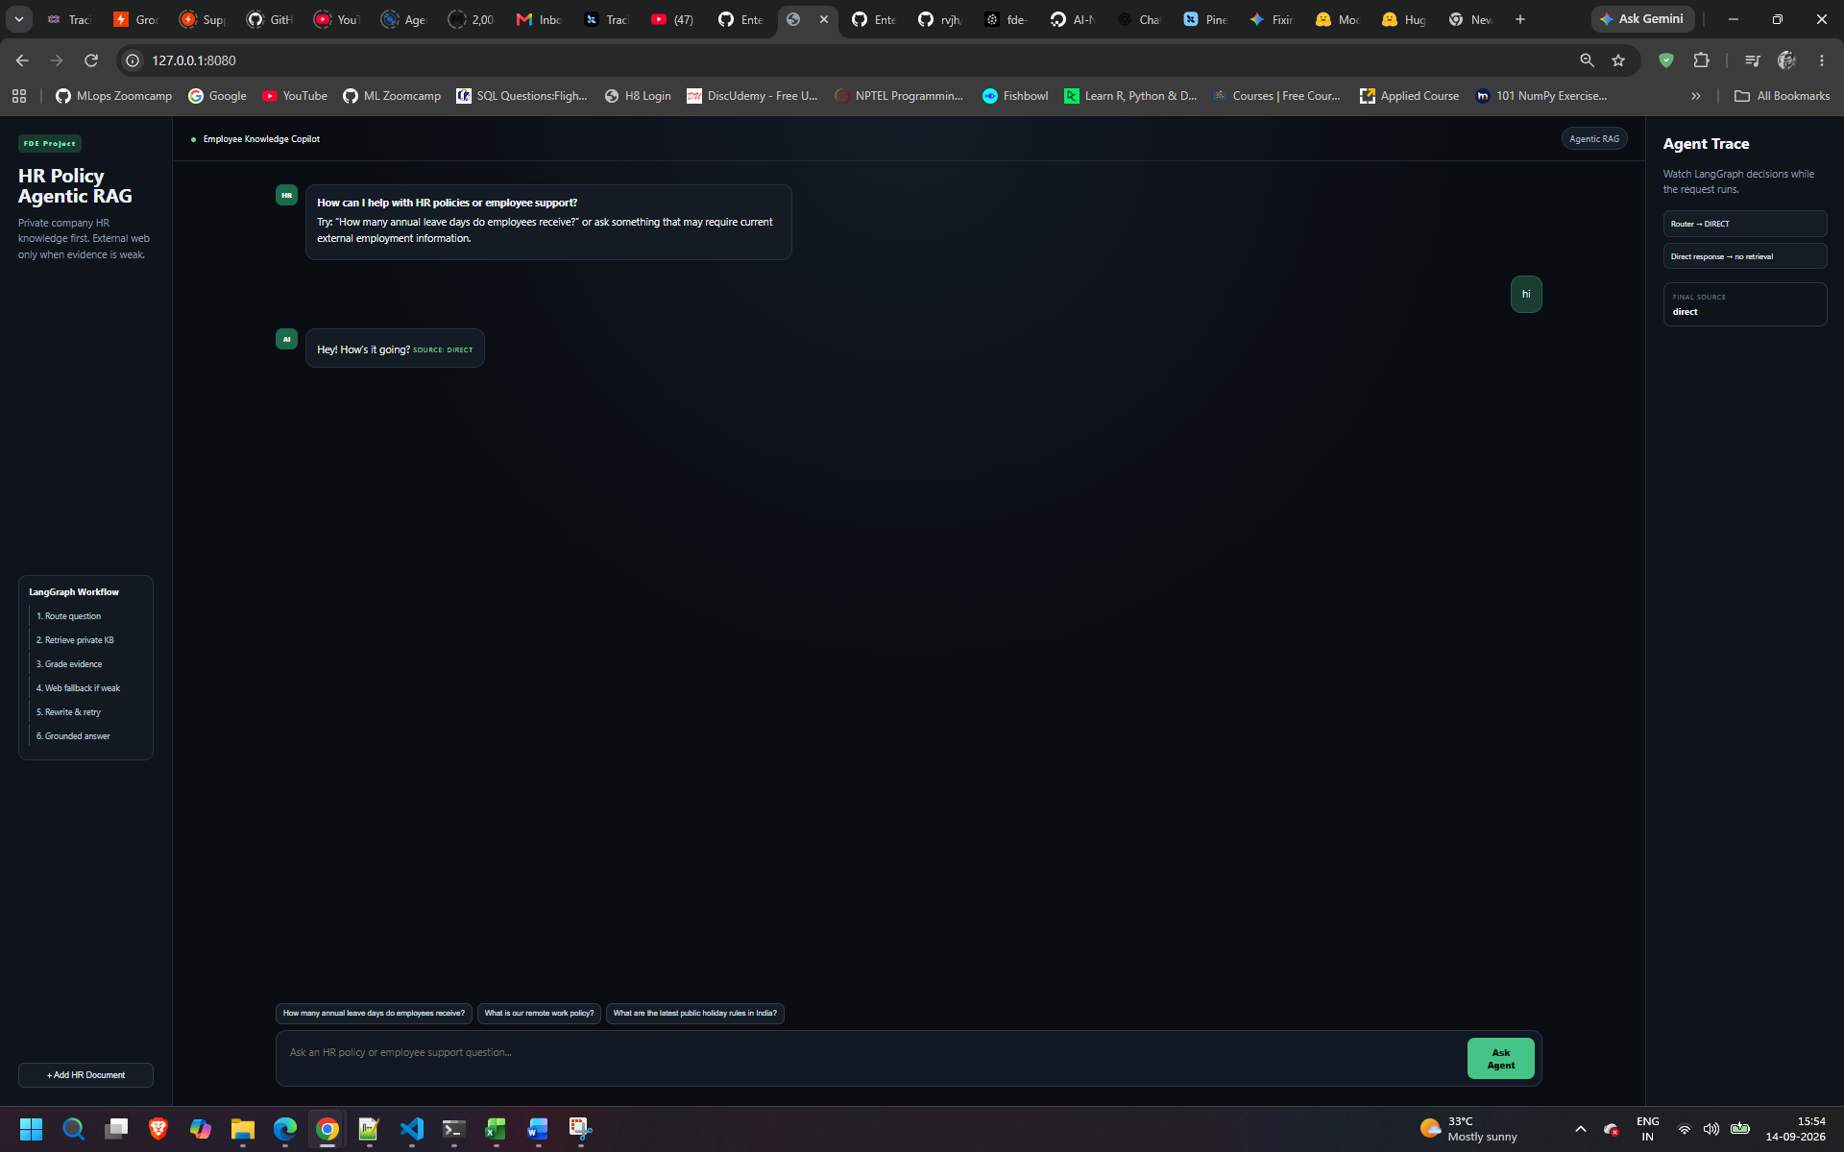
Langsmith Tracing
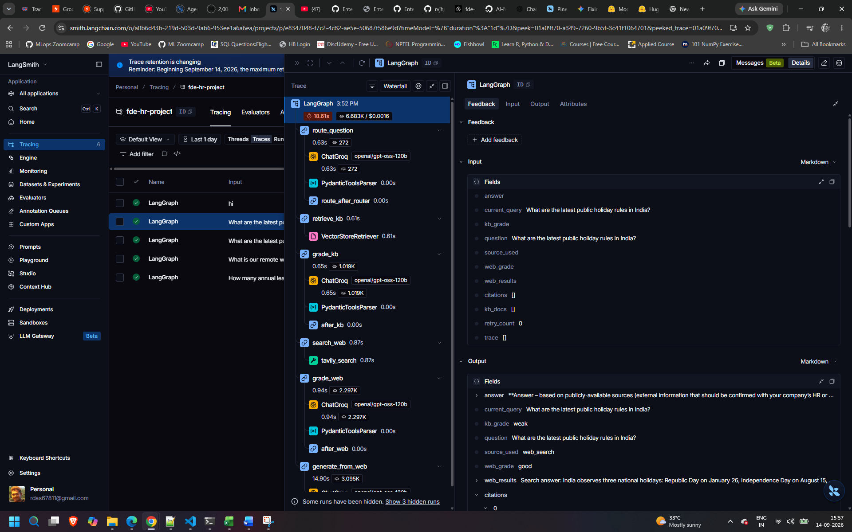

Now productionizing the whole service – Using Docker and Digital service
Create a Dockerfile and .dockerignore
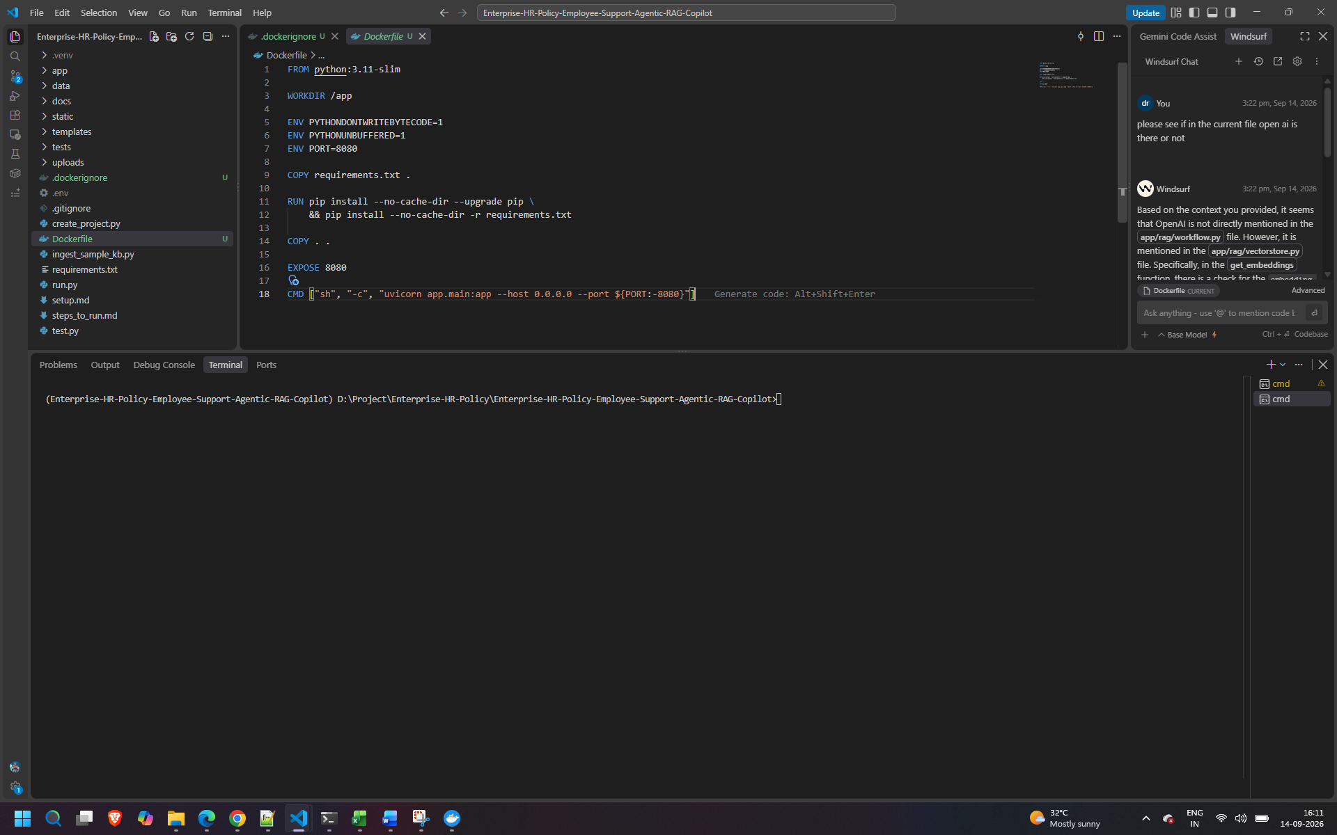
now push all the available changes to git before build
In Digital Ocen – we have app platform
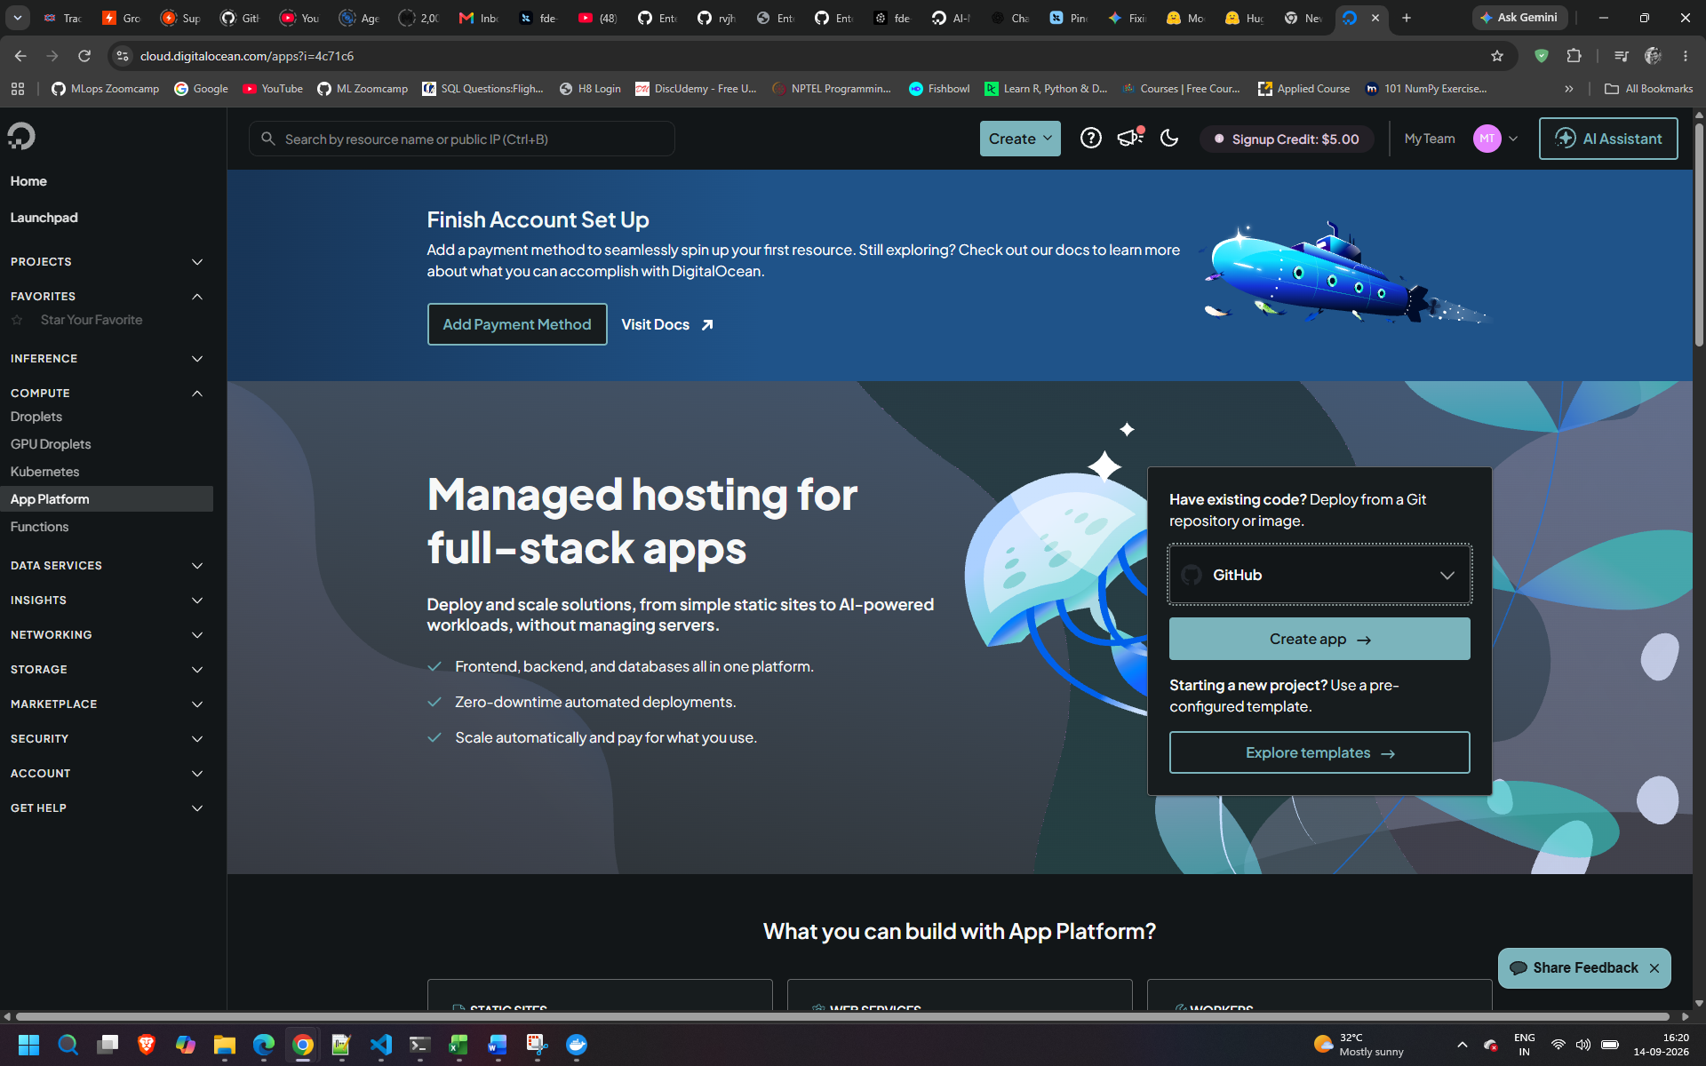
Authenticate with github
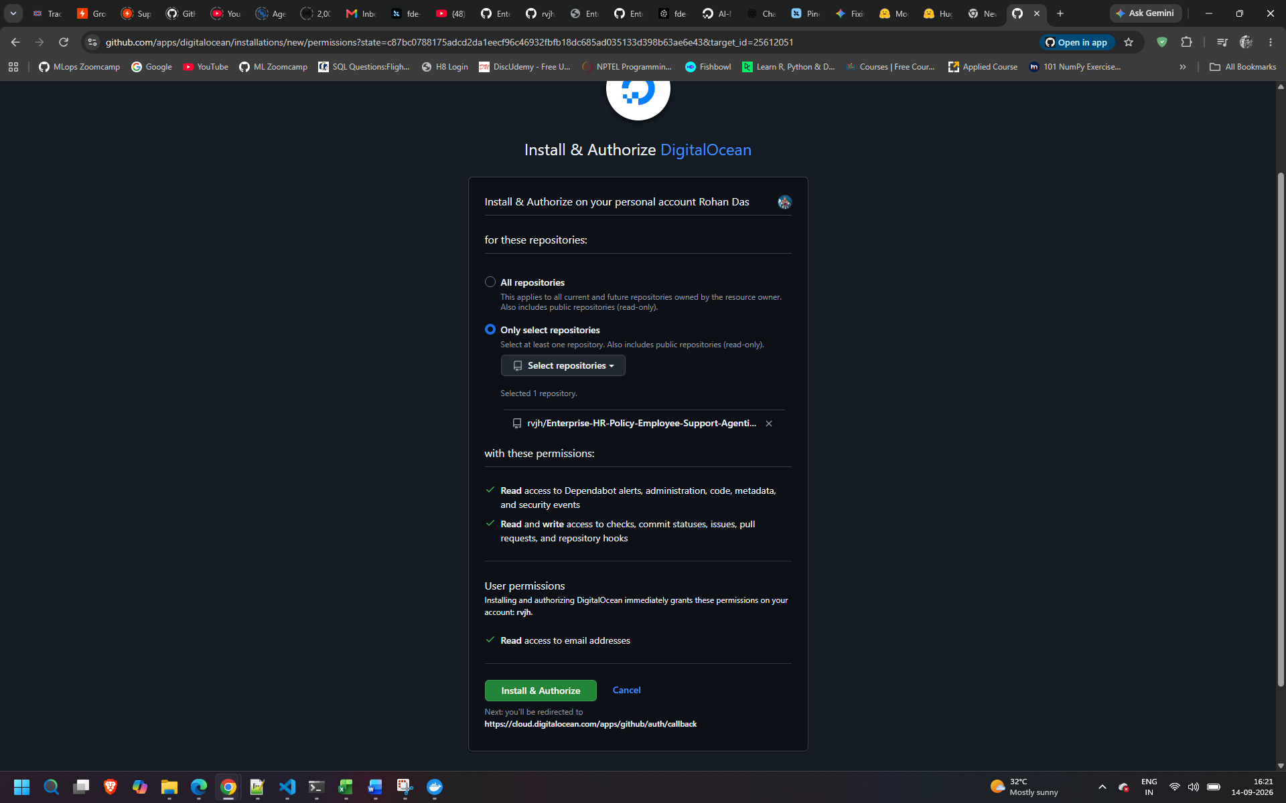
Autodeploy is the ci/cd option – enable it and next
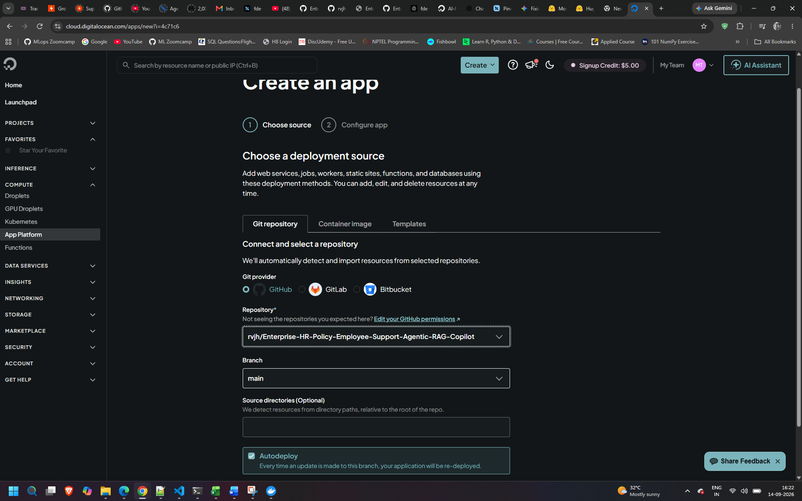
Check info ,source, in size use the bare min 5$/ month
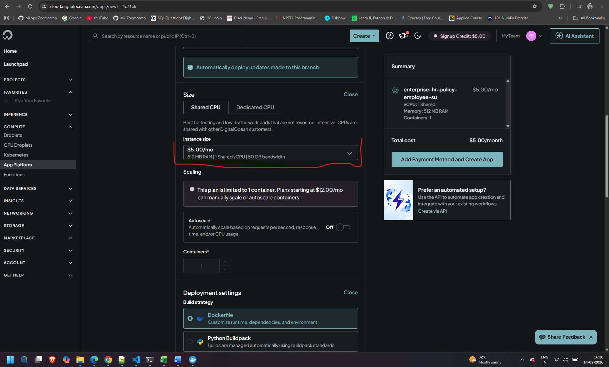
In environment variable copy from local .env
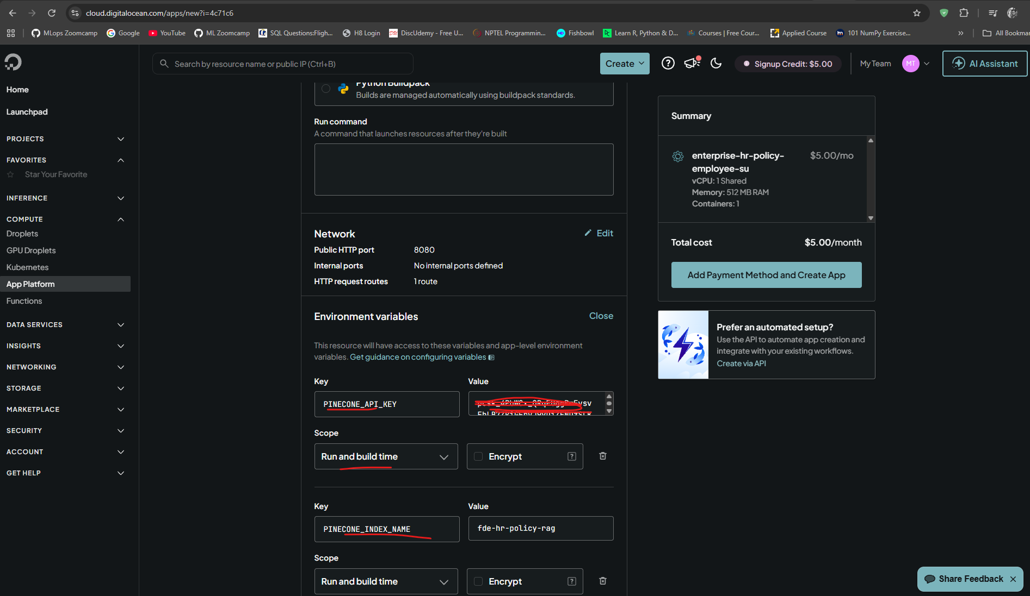
Now fimply click create app
First it will create the docker image then it will get deployed in the DigitalOcean platform
Add payment methods
After deployment click on live app – test the app
